10/12/19
***IMMEDIATE***
BOYACK TO DRIVE HOME SCOTTISH LABOUR MESSAGE ON BBC POLITICS SCOTLAND TOMORROW
Sarah Boyack MSP will tomorrow feature on Politics Scotland to drive home Scottish Labour’s position on key manifesto pledges. It comes ahead of Thursday’s General Election as MSPs gear up for the final push before polling starts.
Boyack said, “Labour remains committed to tackling the housing crisis and homelessness. We especially want to emphasise the importance of electing a Labour government to secure investment in our NHS in Scotland to address waiting times, GP services and sort out the Sick Kids.”
Boyack will also push Scottish Labour’s message on the importance for action on the climate emergency and ending child poverty.

She added, “It’s time for fresh government. What I’m hearing on the doorsteps in Edinburgh is that people are ready for change and tired of the inequalities they see around them every day. I believe Labour will perform well in the election and that our leader, Richard Leonard, has led a strong campaign for us in Scotland.”

Richard Leonard tonight appears with the main Scottish party leaders on The Scotland Leaders Debate at 8pm on BBC One, chaired by the BBC's Scotland Editor Sarah Smith.

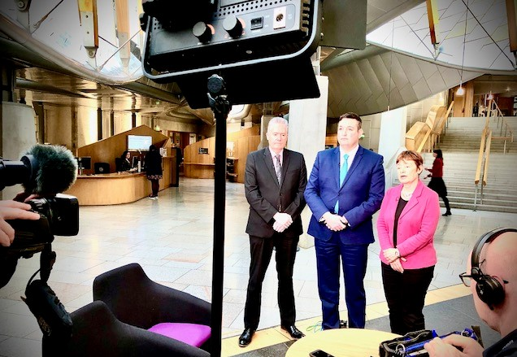
Sarah Boyack, Politics Scotland, November 2019
---ENDS---

Yours sincerely,

