10/12/19
***IMMEDIATE***

BOYACK JOINS EDINBURGH SLEEP WALK AHEAD OF URGENT HOUSING MEETING

Sarah Boyack MSP will join Shelter Scotland’s Edinburgh Sleep Walk tomorrow night to help draw attention to the city’s housing crisis. The charity is encouraging people to join them on an hour-long walk around the city on what promises to be a cold and wintry night.
Boyack, MSP for Lothians, said, “It’s important we do as much as we can for those who have fallen through the cracks in this housing crisis brought on by austerity. Endless cuts have left people far worse off, and this is the worst time of year to be living on the streets. I hope this event will raise awareness and the funds that Shelter desperately needs to help protect our most vulnerable citizens.”
It comes as it was announced that a petition with 10,000 signatures will be presented to the Scottish Parliament, calling for legislation to secure a legal right to a home. Annie Lennox, KT Tunstall, Robert Carlyle and Val McDermid are among the signatories as Scottish Government figures show that homeless applications have increased to 36,465 in 2018-2019, up three per cent from the previous year.
Boyack added, “If the SNP had spent as much time and resources directing money into affordable homes and social housing as they have time on large-scale, failed hospital projects, perhaps this housing crisis would not be as acute as it is now.”
Ms Boyack last week criticised Edinburgh City Council housing waiting lists, calling them “meaningless” after dozens of constituents listed complaints about housing including homes with mice infestations, anti-social behaviour, no access for people with disabilities and families struggling with children in cramped conditions.
Ms Boyack will meet with Edinburgh Council housing officials on Monday address the matter, saying, “Essentially, being placed on the housing waiting list is meaningless. It offers no reassurance or guarantee to people that they will ever receive suitable accommodation, whether it is a family of four in a two-room flat, or newly-homeless single adults.
“A new law is urgently needed to protect the homeless and those at risk of homelessness. It simply isn’t good enough and I will address these matters urgently at the Edinburgh Council meeting on Monday.”
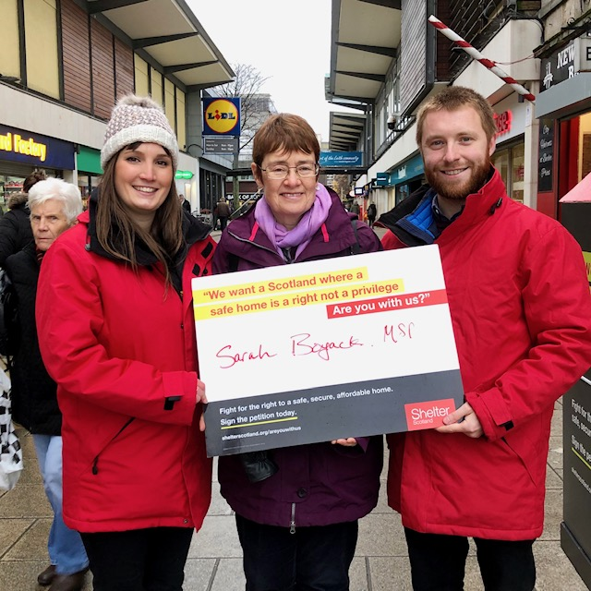
Sarah Boyack with Shelter Staff offering support at Shelter’s Are You With Us? campaign last month.
---ENDS---

Yours sincerely,

